**Software Development/ Excellence Cell**

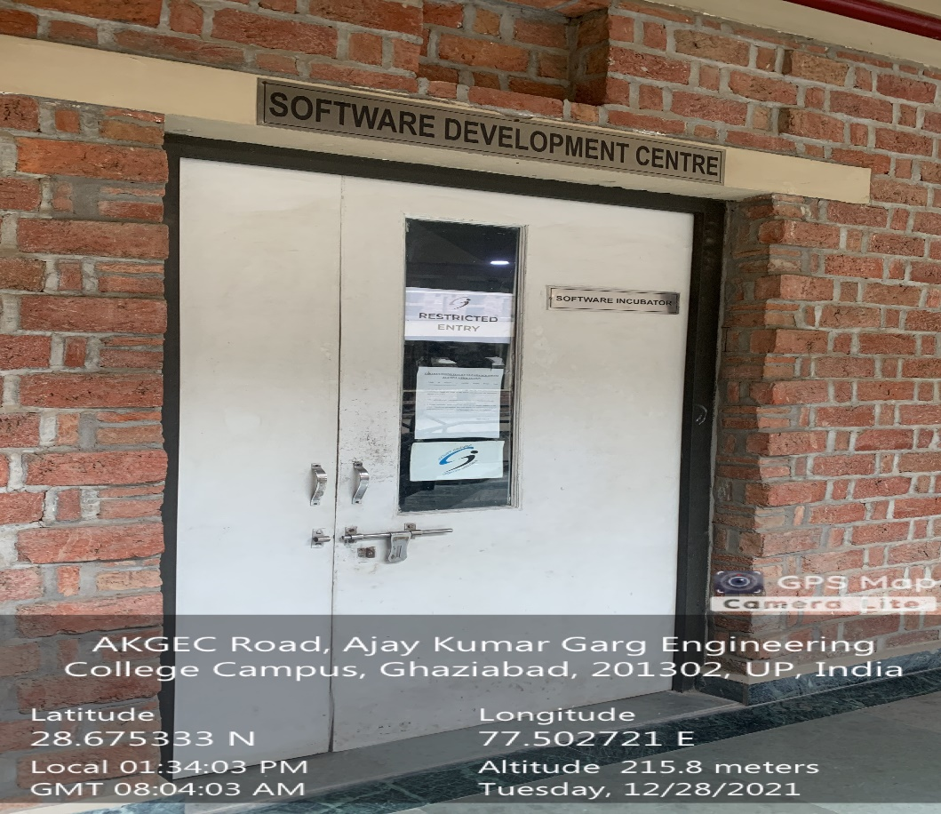

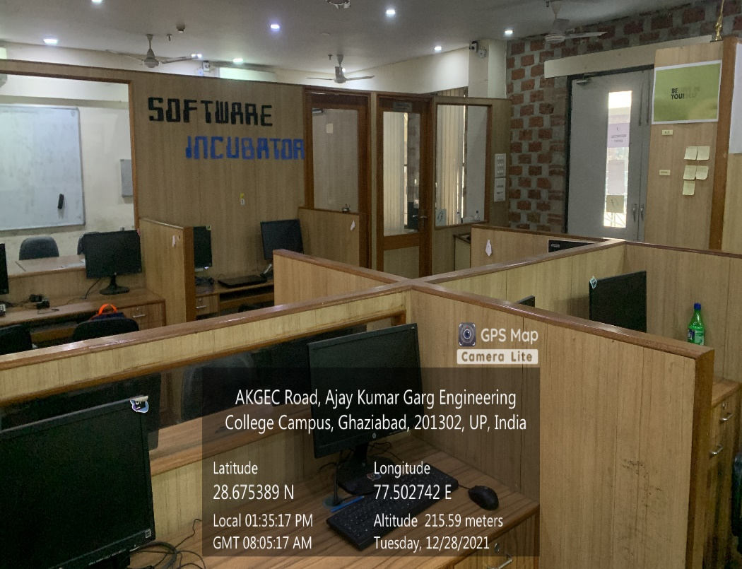

**CSIT BLOCK, THIRD FLOOR, SOFTWARE DEVELOPMENT CENTER**

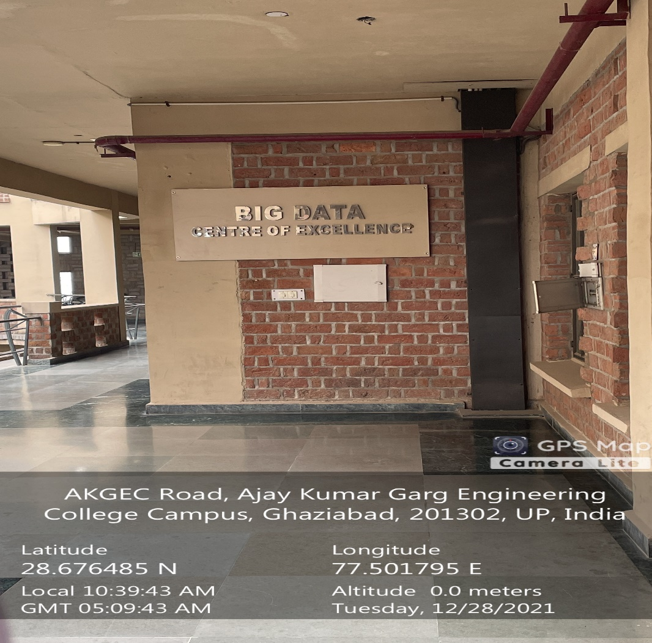

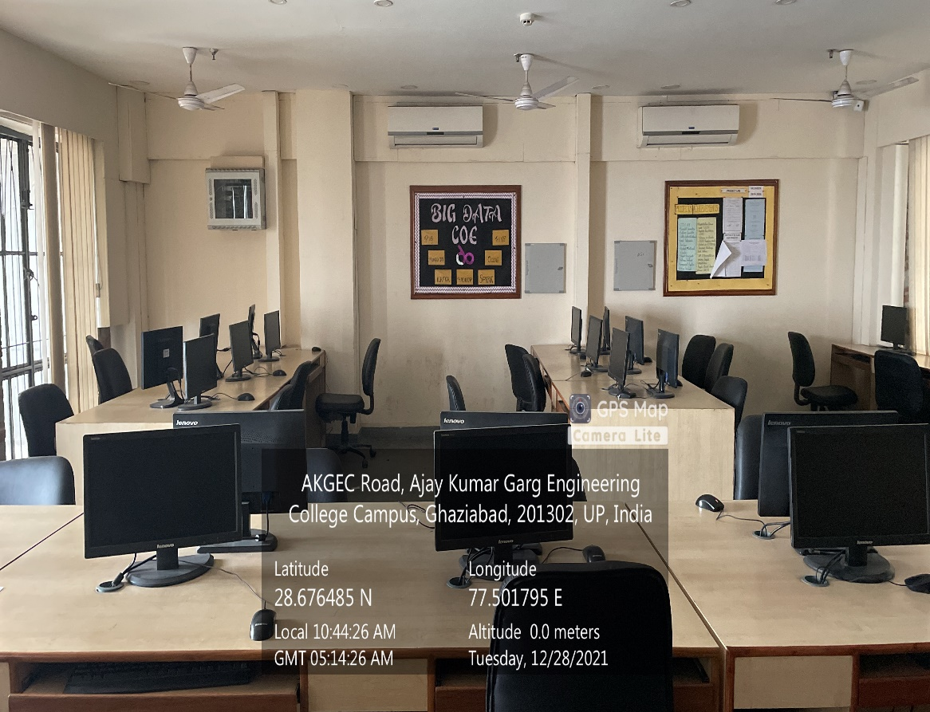

**CSIT BLOCK, THIRD FLOOR, BIG DATA CENTER OF EXCELLENCE LAB**

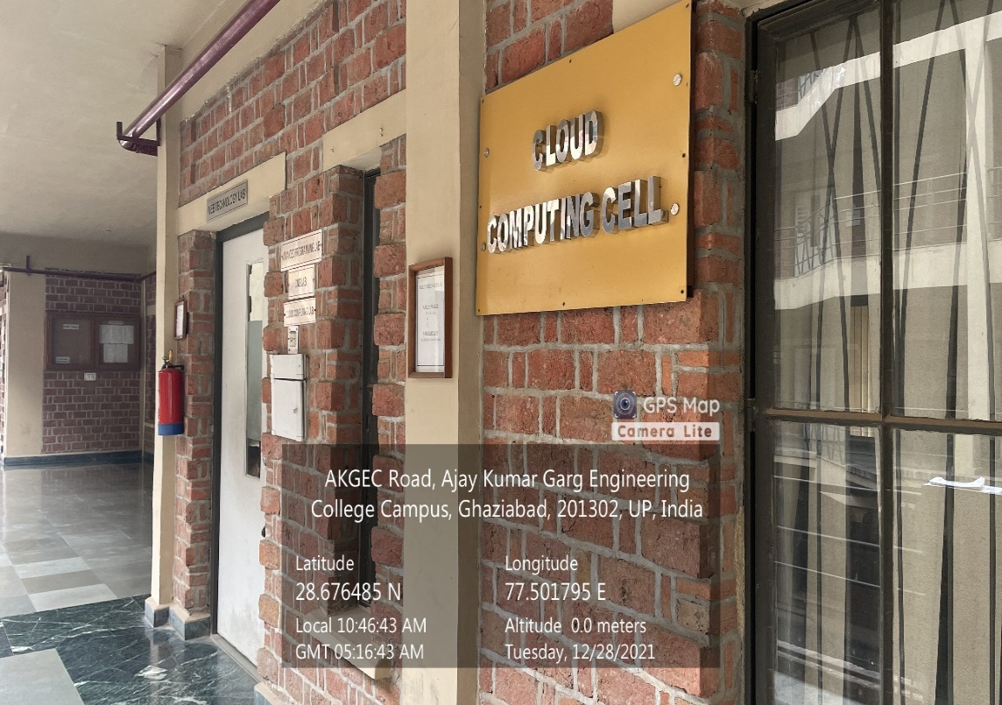

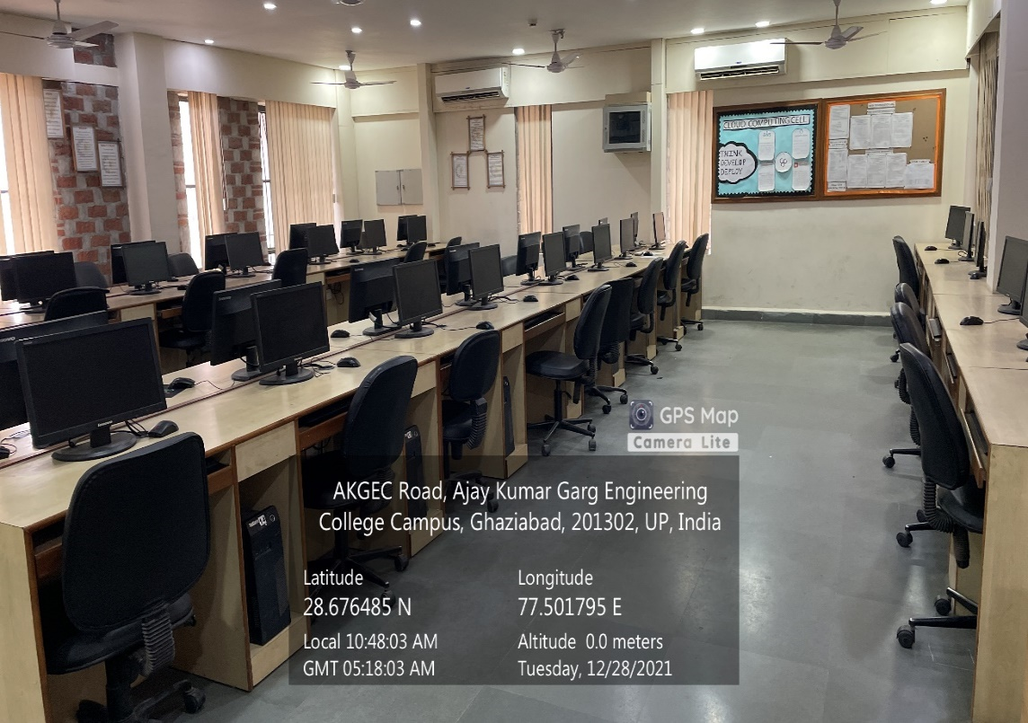

**CSIT BLOCK, THIRD FLOOR, CLOUD COMPUTING CELL**

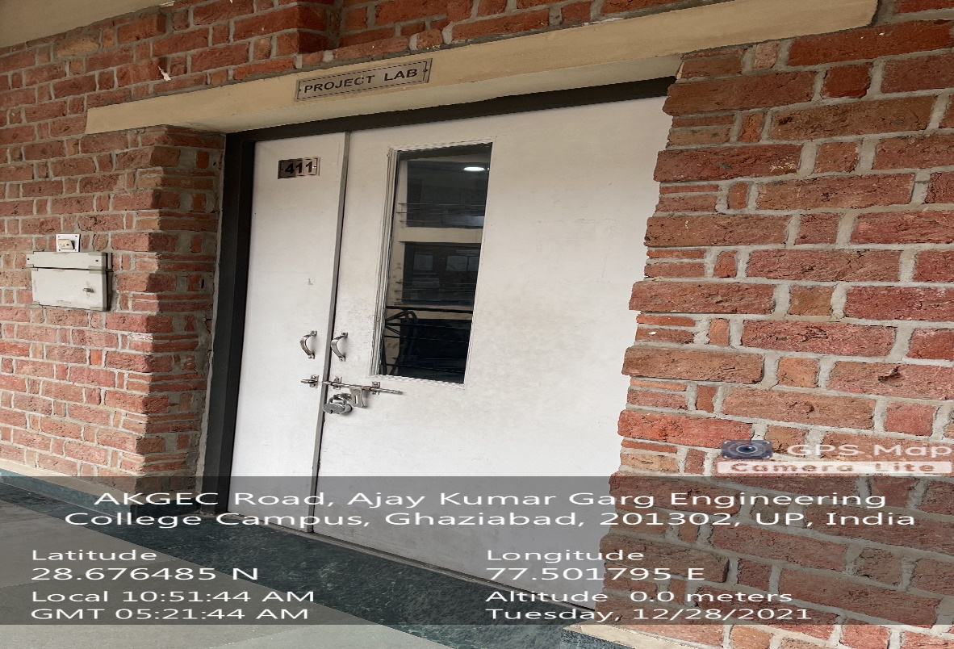

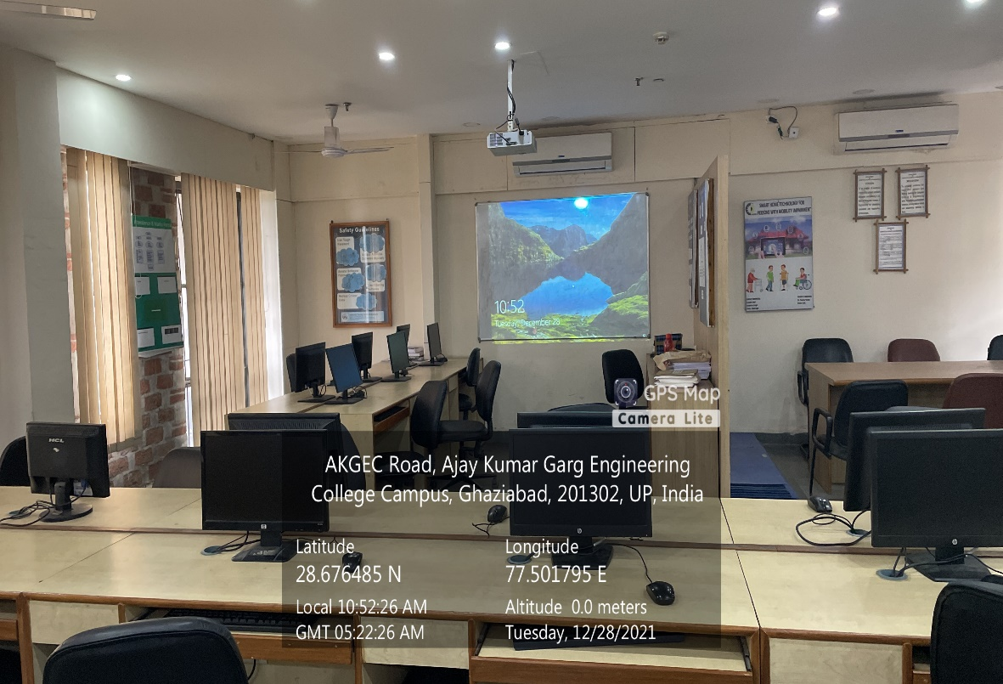

**CSIT BLOCK, THIRD FLOOR, OPEN SOURCE SOFTWARE LAB**

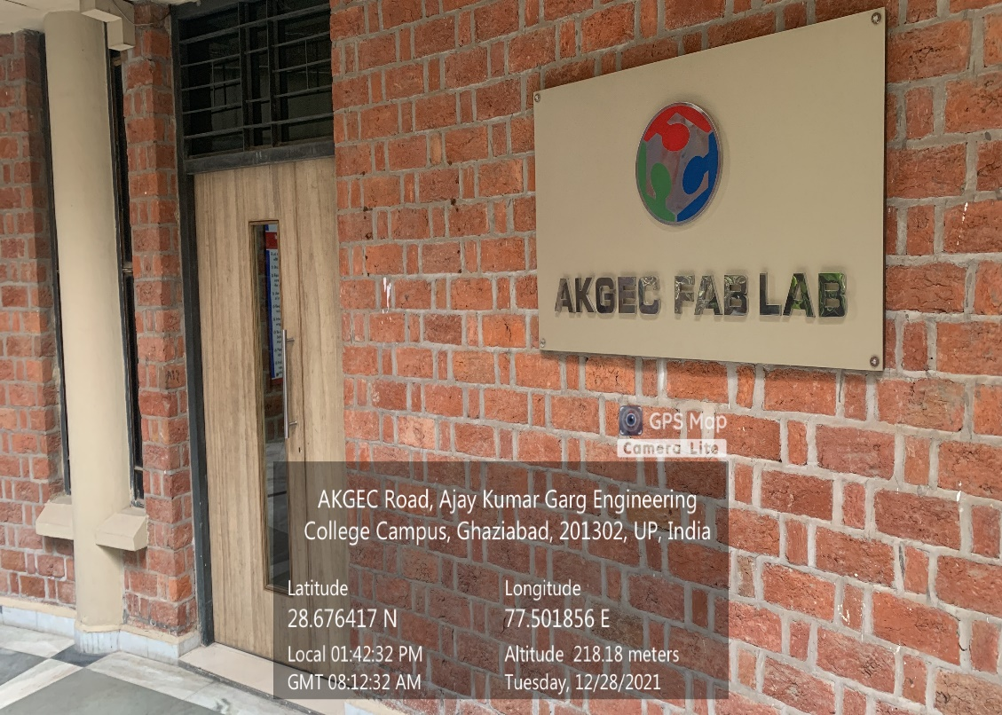

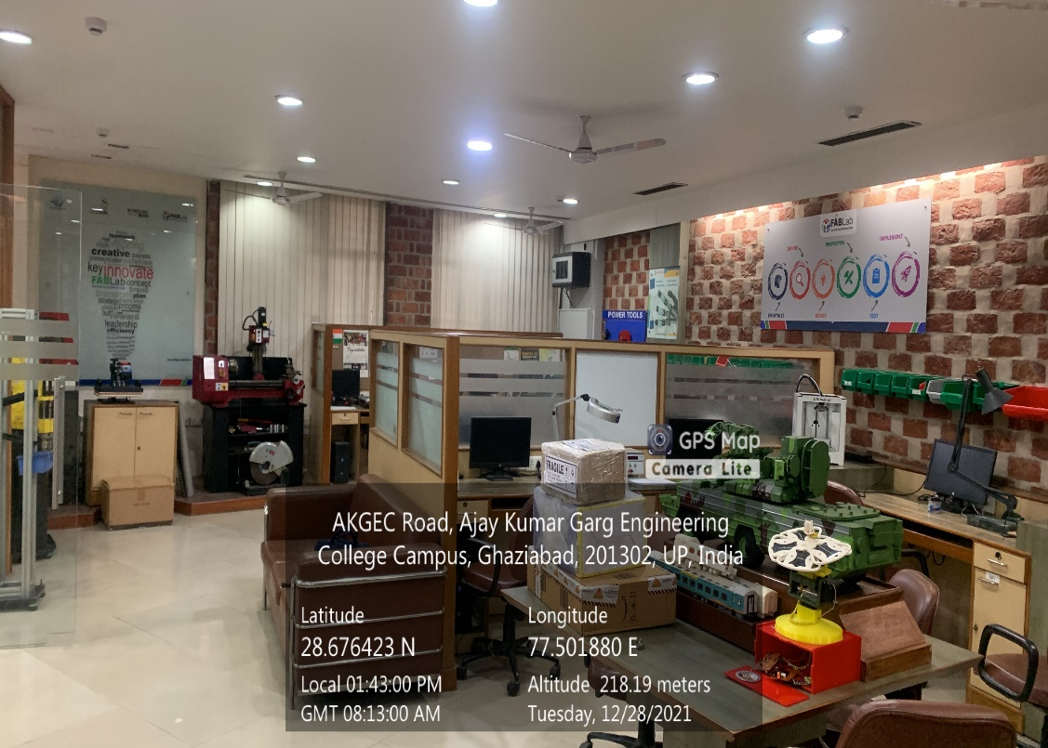

**MECHANICAL BLOCK, GROUND FLOOR, CENTER OF EXCELLENCE (FAB LAB)**

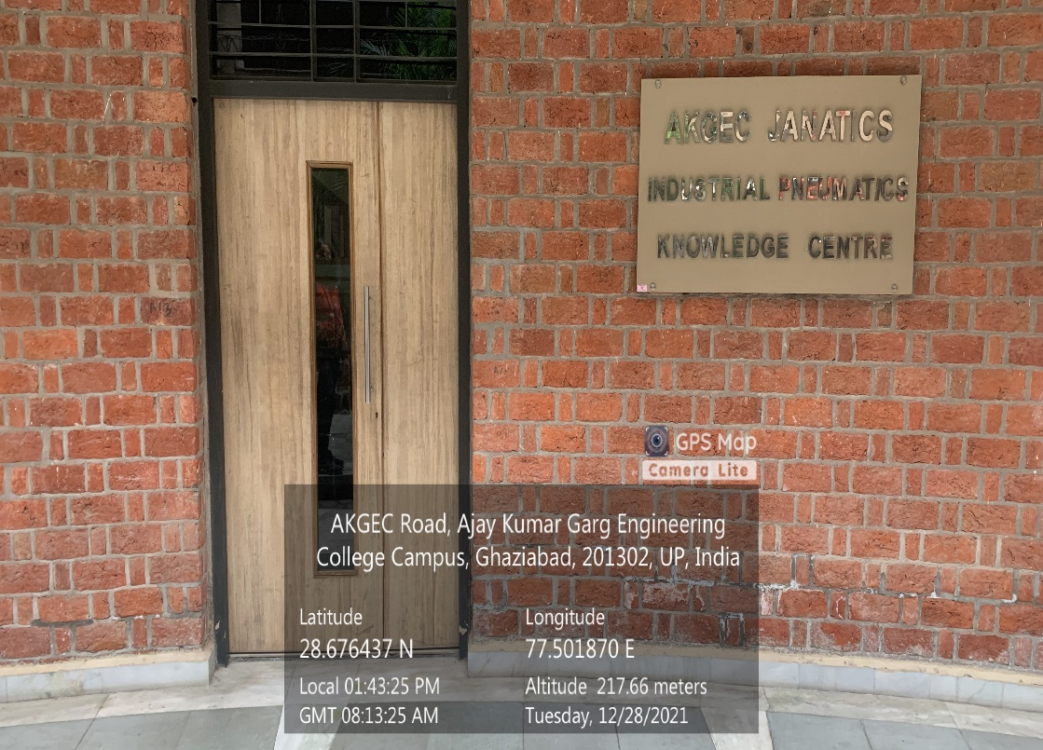

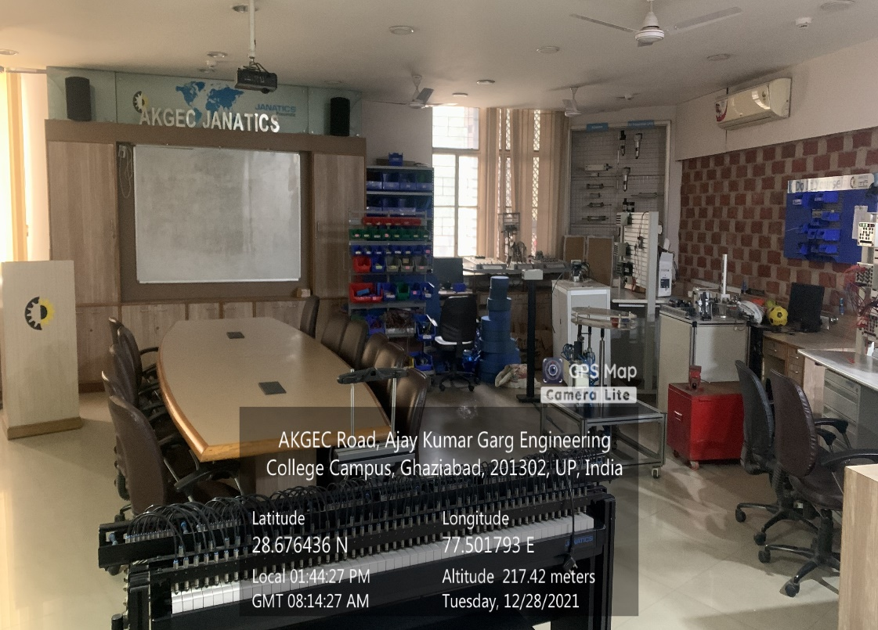

**MECHANICAL BLOCK, GROUND FLOOR, CENTER OF EXCELLENCE (INDUSTRIAL PNEUMATICS)**

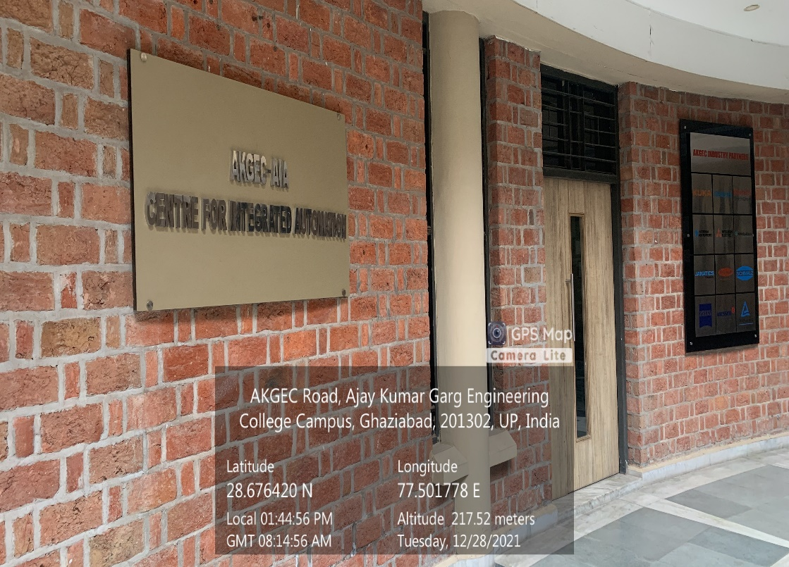

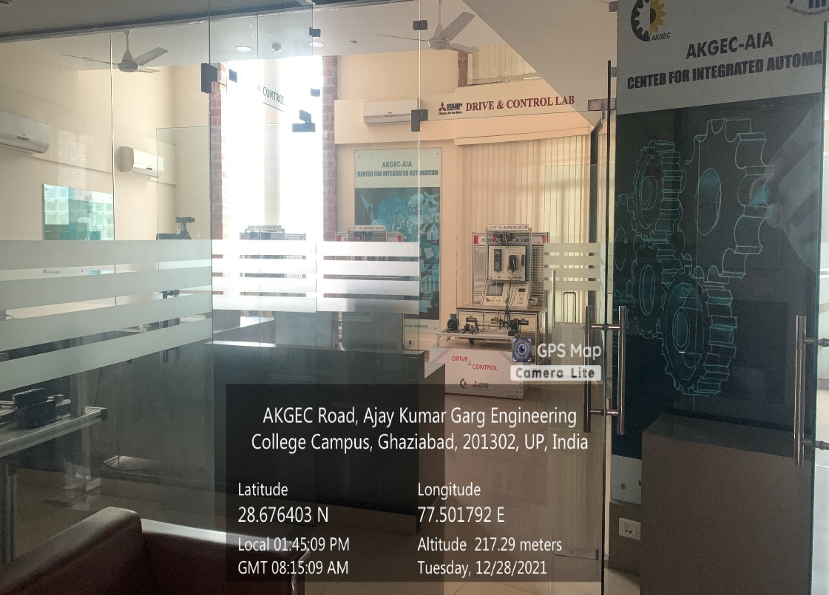

**MECHANICAL BLOCK, GROUND FLOOR, CENTER FOR INTEGRATED AUTOMATION**

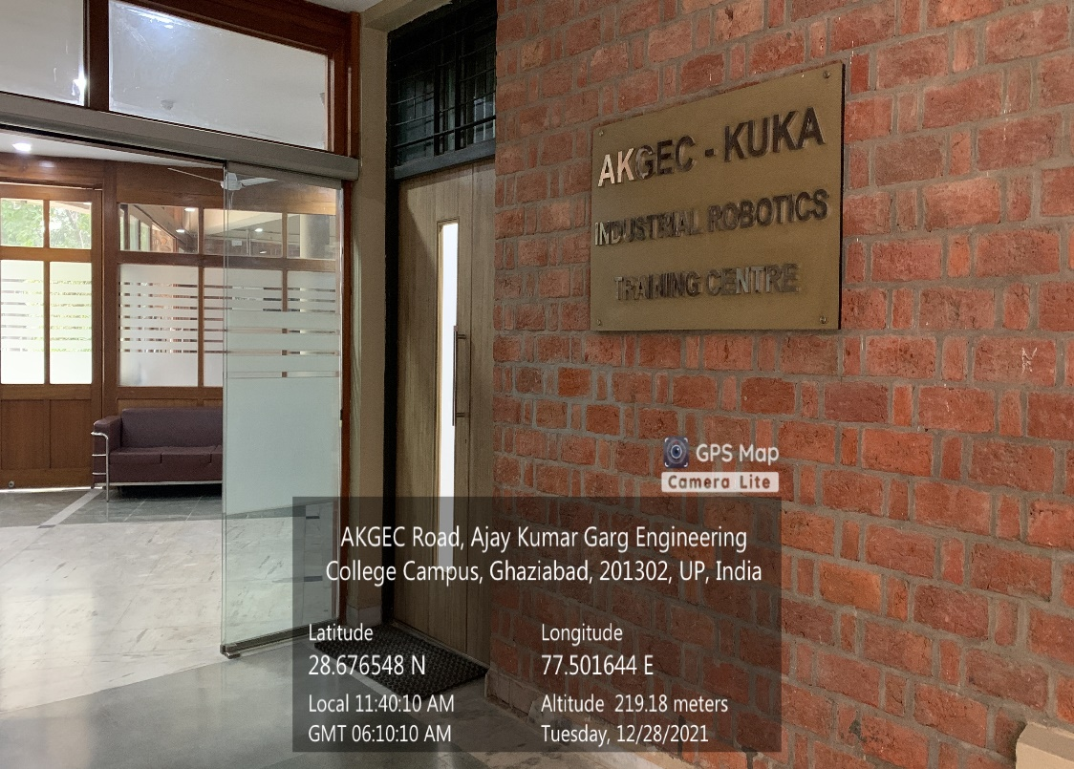

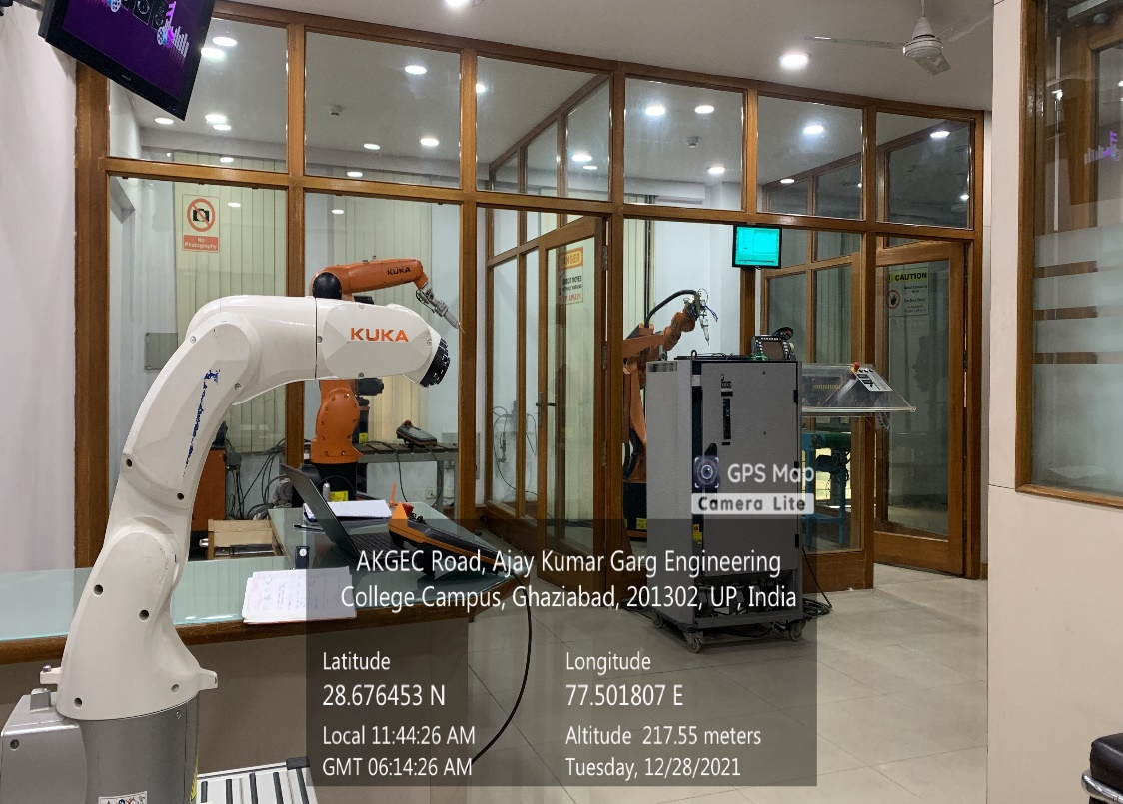

**MECHANICAL BLOCK, GROUND FLOOR, CENTER OF EXCELLENCE (KUKA LAB)**

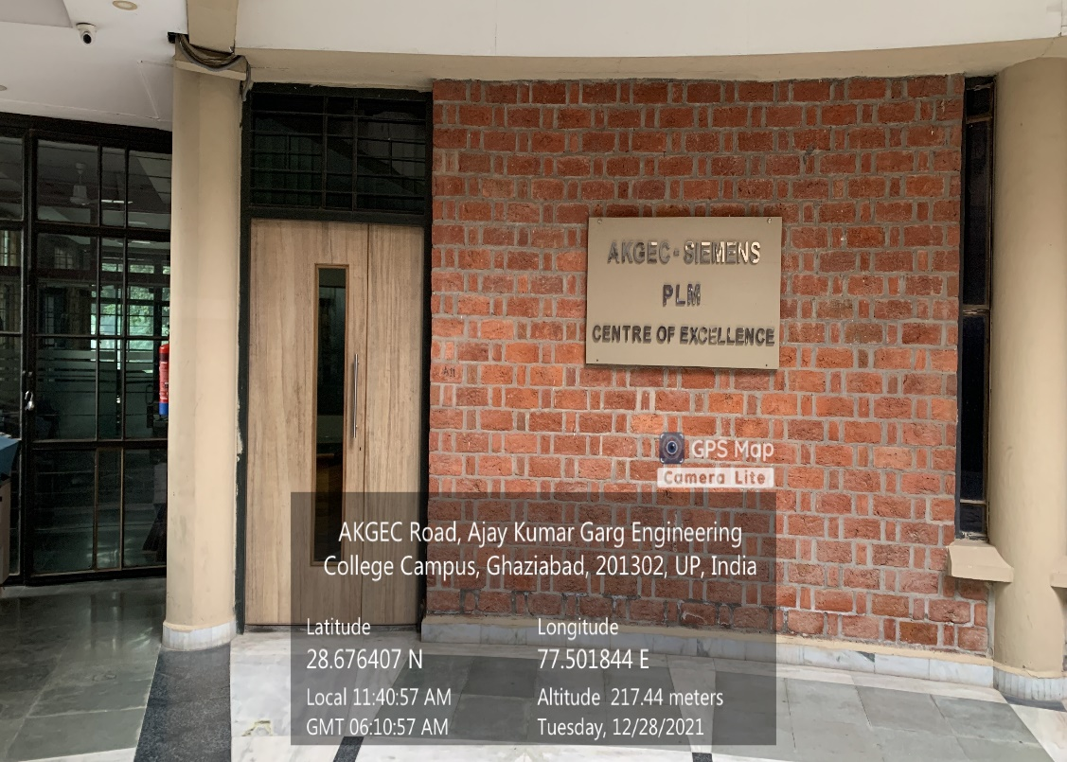

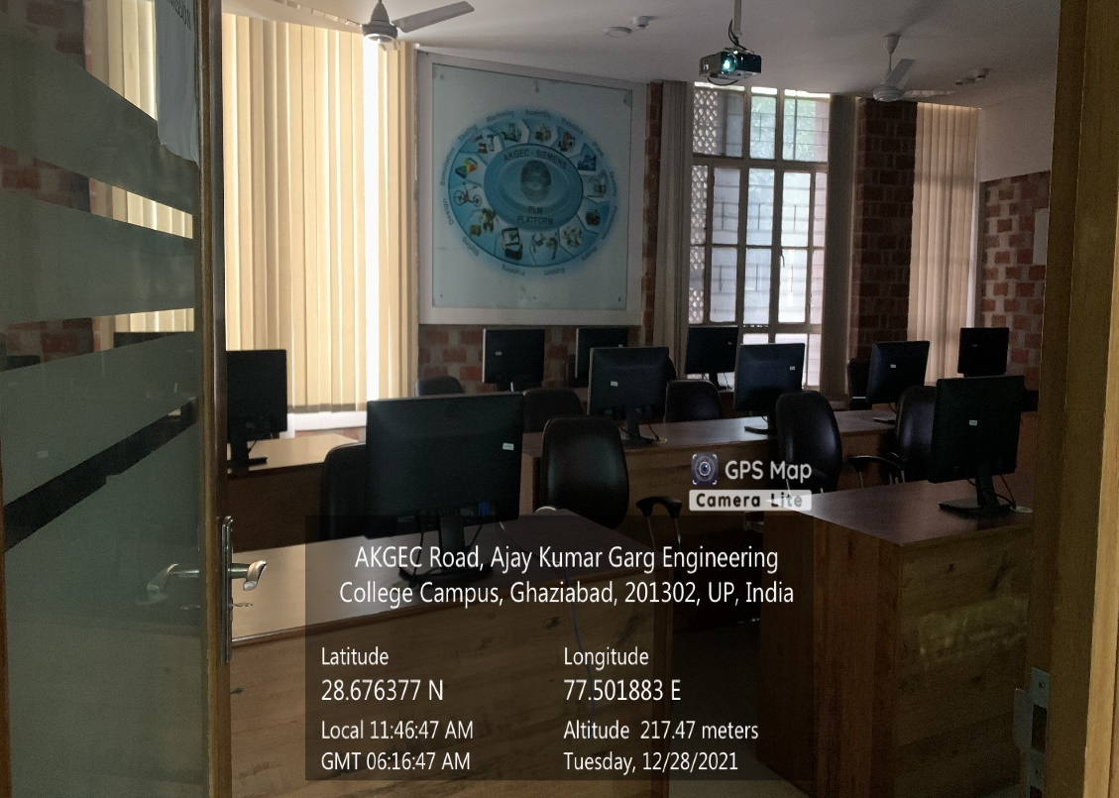

**MECHANICAL BLOCK, GROUND FLOOR, CENTER OF EXCELLENCE (SIEMENS LAB)**

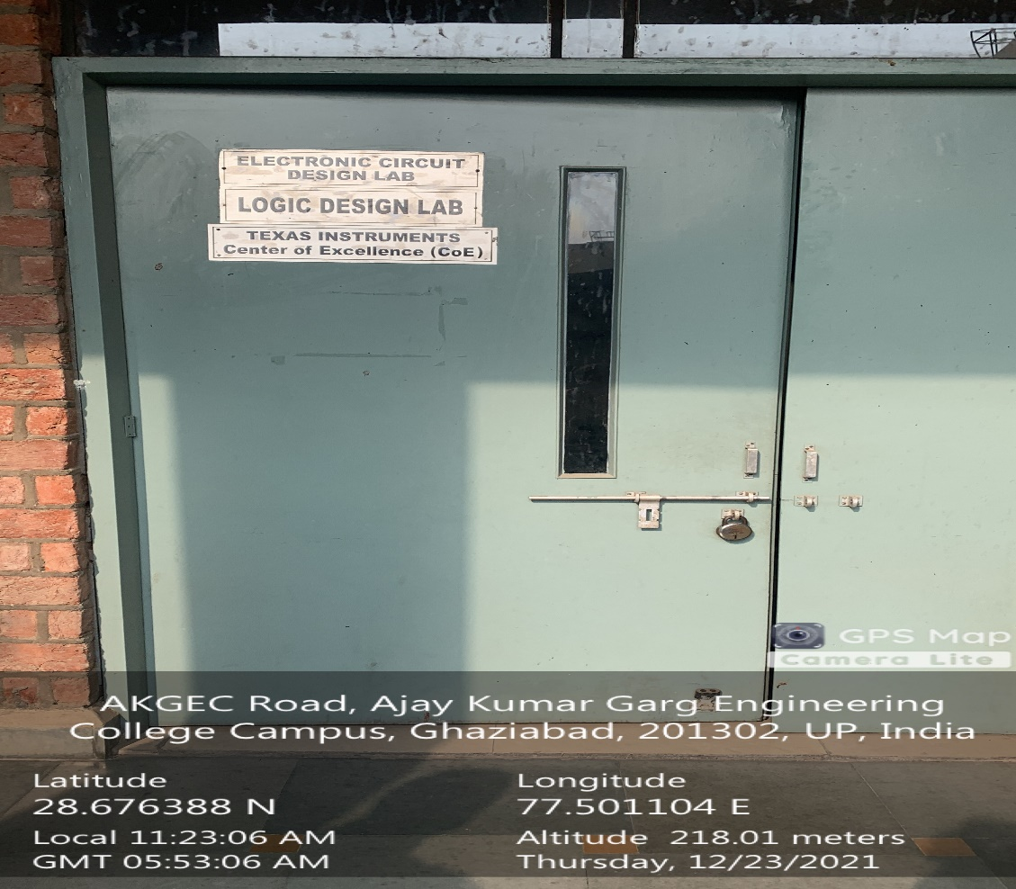

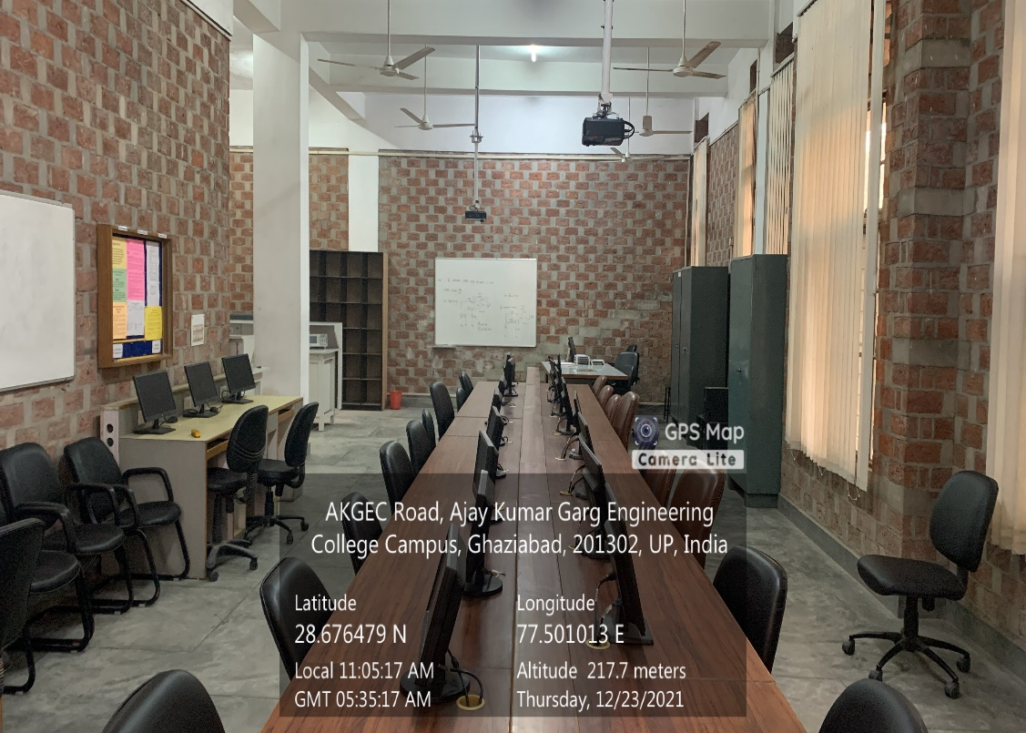

**MECHANICAL BLOCK, GROUND FLOOR, CENTER OF EXCELLENCE (TEXAS INSTRUMENTS)**